What They Said About Libraries …
Quotes from Member States at the 41st meeting of the
Standing Committee on Copyright and Related Rights,
World Intellectual Property Organisation

Bangladesh

[Statement on behalf of the Asia and Pacific Group (APG)]

For the APG, limitations, and exceptions for libraries, archives, museums, educational and research institutions, as well as persons with other disabilities are of critical importance to individuals and the collective development of societies. While we appreciate the work that has so far been done, we believe that we have still a lot to do. COVID-19 has made a profound impact on the copyright ecosystem and its stakeholders; not only rights-holders, but users too, have had to respond to the pandemic’s increased demands for creating, distributing, and accessing works remotely. Now is the time to begin our planning for finalizing a program of work to move forward on this particularly important matter. In this regard, we welcome the idea of holding regional consultations with the participation of member states and relevant stakeholders after SCCR/41. […]

Mr Chair, there is no denying that COVID-19 has greatly affected all facets of our lives including the IP arena and areas of copyright and related rights in particular limitations and exceptions which are no different. Mr Chair, it is evident that the advent of the pandemic caused the largest disruption in the sectors of copyright and related rights in history across the world. Authors, publishers, and the creative industries went through so many challenges. Educational institutions were shut down and the traditional mode of teaching was shifted to online classes. Libraries, academics, and students faced a lot of difficulties to access online resources in many countries, both in terms of available online educational and resource materials, as well as technicalities. Moreover, all the countries do not have the same technical and technological capacity as well as the endowment of online resources to fairly benefit from this e-learning system. This has been an unprecedented experience. The countries, particularly the developing ones are still struggling with the consequences of the pandemic in the areas of education, research, culture and access to knowledge. In this case cross-border cooperation or some standard international norms could help countries overcome this situation. Unfortunately, we do not have any such arrangements for international settings that could have enabled countries to respond to the challenges in a collaborative spirit. Mr Chair, this is true that the pandemic is not the only issue that adversely affects the overall aspects of copyright. Yet, it has shown us how the situation could worsen in case of copyright limitations and exceptions under extraordinary circumstances. It has also prompted many to rethink the role of copyright ensuring access to educational and resource materials as well as protecting the rights of the creators of the copyrighted works in these kinds of situations. In this backdrop the absence of an international instrument on limitations and exceptions has been widely felt. […]

Brazil

It is our view that the agenda should continue for now with a focus on the points where there seems to be some consensus that is, preservation and cross-border issues. This would be without prejudice to the adoption of national or regional solutions on these and other issues of the limitations and exceptions agenda. In SCCR/40, my delegation raised the issue of limitations and exceptions regarding people with other disabilities not covered by the Marrakesh treaty. We see room for a more in-depth exchange on this matter. We would therefore propose that future regional or subregional seminars address the issue of limitations and exceptions regarding people with other disabilities, with a focus on new technologies and accessibility. I would also like to share with members recent developments regarding the implementation of the Marrakesh treaty in Brazil. The text of the law that will discipline aspects related to the treaty should be finalised soon. It is the result of intensive consultations within the Brazilian government and with the civil society. […]

Chile

As a delegation we believe that exceptions and limitations are very important for balance in the copyright system. We obviously see that there have been very significant difficulties caused by the COVID-19 pandemic and, in the issue of distance learning, access to museums and archives demonstrate the importance of exceptions and limitations for allowing access during events such as this health pandemic. It is very important for us to reflect on how this Committee can continue with our work that has been interrupted by the pandemic, and we believe that our future work needs to be strengthened with international guidelines, at least with regard to the area of education, libraries and archives. […]

Finally, we would like to point out the importance of a balanced approach and also looking at exceptions and limitations, which will hopefully be able to lead us towards consensus. However, we all need to make an endeavour to reach a consensus on how to respond to the needs of the broadcasting organisations while preserving the rights of the public and accessing information. Safeguarding the balance of rights has been in the public interest and are essential elements that should be taken into account in further consideration of the broadcasting treaty. Broadcasting continues to play a key role in accessing knowledge and culture in many countries so it is imperative to take this agenda forward without creating a new layer of rights which might negatively affect the right to access information. […] value for the future generations. […]
Georgia

[Statement on behalf of the Central European and Baltic States (CEBS) Group]

The CEBS group is convinced of the importance of libraries, archives and museums as well as the educational and research institutions in the social and cultural development of our societies. And consequently, welcomes the work undertaken. We also notice with interest the work already done in various member states which have recently introduced exceptions and limitations in their national systems, and we look forward to continuing discussions as we find the evidenced-based approach very important. […]
India

As far as limitations and exceptions are concerned, in order to to maintain an appropriate balance between the interests of the rights holders and users of protective works, copyright laws allow certain limitations of economic rights, that is cases in which protected works may be used without the authorization of the right holders, and with or without the payment of compensation. The submissions made at the time of the 39th session were taken forward in the 40th session, that is that limitations and exceptions are necessary to facilitate the work of libraries, archives, and for the educational and research institutions and persons with disabilities. So, we state our views and support the limitations and exceptions being proposed and will look forward to engaging with more details in the coming sessions. […]

Indonesia

With regard to the area that is of interest for this delegation, we hope that one of the next steps in our deliberation on the broadcasting treaty would also address the Limitations and Exceptions provisions within the Chair’s text. Limitations and Exceptions to broadcast rights are essential, including but not limited to, L&E for the purpose of digital preservation, online education and research. We hope that the treaty, as is the case with all WIPO copyright and related rights treaties would achieve a balance of exclusive rights and exceptions, taking into account the larger public interest, particularly on access to information. […]
We share the view that COVID-19 pandemic has disrupted all aspects of our lives. Even now, many parts of the world are still struggling with these new conditions. We have seen how libraries, archives and museums had to be closed or adapt the way that they deliver their services to the public, while research and education institutions have had to adapt to online teaching and remote working. While putting public health and safety at the forefront, governments need to ensure all stakeholders have access to knowledge, education, research and culture. With this in mind, we urge members to support a proposal to hold an information session on the impacts of COVID-19 on the copyright framework, including rights, related rights and limitations and exceptions, at the 42nd session of the SCCR. We believe that this would be inherently balanced as it approaches the issue in a holistic manner while within the mandate of the SCCR. We are sure much can be learned from the Secretariat, experts and relevant stakeholders as we also try to cope with these unprecedented challenges. Mr Chair, turning to the agenda for limitations and exceptions, Indonesia believes that it is important that we continue our work on the Limitations and Exceptions agendas in accordance with the General Assembly mandate of 2012 for the SCCR to work towards an appropriate international legal instrument or instruments on the topic of limitations and exceptions. With the completion of the action plan, we must now define a new plan of working for advancing the issue on limitations and exceptions. In this regard we need to build on the previous work plan which has identified many themes apparently themes to work on at the international level toward harmonization including preservation and cross-border issues and online uses. […]Indonesia is of view that is important for us to commence concrete work leading to the achievement of the mandate of the 2012 assembly. This could be done by agreeing in a concrete work plan with appropriate outcome ranging from model laws, interpretations, declarations or any other appropriate instruments. […]
iran

The COVID-19 pandemic has shown us the need to interpret and implement all copyright and related rights treaties with flexibilities to protect public health and public interests during the health crisis […]. Mr Chairman, striking an adequate balance between copyright protections and promoting dissemination and use of works in the public interest through creating a limitations and exceptions regime in the form of an international legal instrument constitutes the basis for the SCCR mandate of the General Assembly in 2012. […]Mr Chairman, differences in national legislation with regards to the exceptions and limitations in the copyright system are bound to block the flow of knowledge, and to overcome that requires an international framework to harmonize national legislations. We are of the conviction that norm setting is the only way to ensure that WIPO members provide a basic level of modernized limitations and exceptions for such institutions.

Mexico

But, in some other ways that will help us to reflect and seek solutions at a global level with the objective to prioritise the supreme interests of girls, boys, adolescents and young people in the exercise of the right to education. For example, moreover, that from the local level we are creating public policies that promote the development of scientific, research, innovation, development, and technological modernization inter alia. Recently in Mexico, we have promoted a new general law of libraries to respond to the current situation, and policies have been drafted to establish support and organise public libraries to establish basic standards for the functioning of the national network of public libraries and we are proposing guidelines for the integration of the national system of libraries. […]
Pakistan

Pakistan appreciates the immense amount of work undertaken to examine and understand the issue of exceptions and limitations. As also highlighted in the report, exceptions and limitations are an integral and natural part of a balanced copyright system. The practices and understandings of the copyright limitations and exceptions vary across countries. Therefore Pakistan reiterates its support for the formulation of a baseline international instrument to act as legislative assistance and as an umbrella guideline for the member states to revise and redraft the statutes accordingly. We are hopeful the report by the Secretariat will translate into a meaningful and tangible work program on the issues of limitations and exceptions. Mr President, the impacts of COVID-19 have exacerbated the challenges associated with copyright exceptions and limitations. The shutdown of education institutions during the pandemic and shift towards e-learning systems added to an already volatile situations related to copyright exceptions and limitations, particularly in developing countries. As pointed out, in the Asia-Pacific Group intervention, cross-border cooperation or some standard international norm could help countries overcome this situation.
As for possible next steps, Pakistan is of the view that more attention we should be given to the issue of limitations and exceptions in the future of a broadcasting treaty, particularly with regards to education, research and access to information with the aim to serve larger public interests. […]
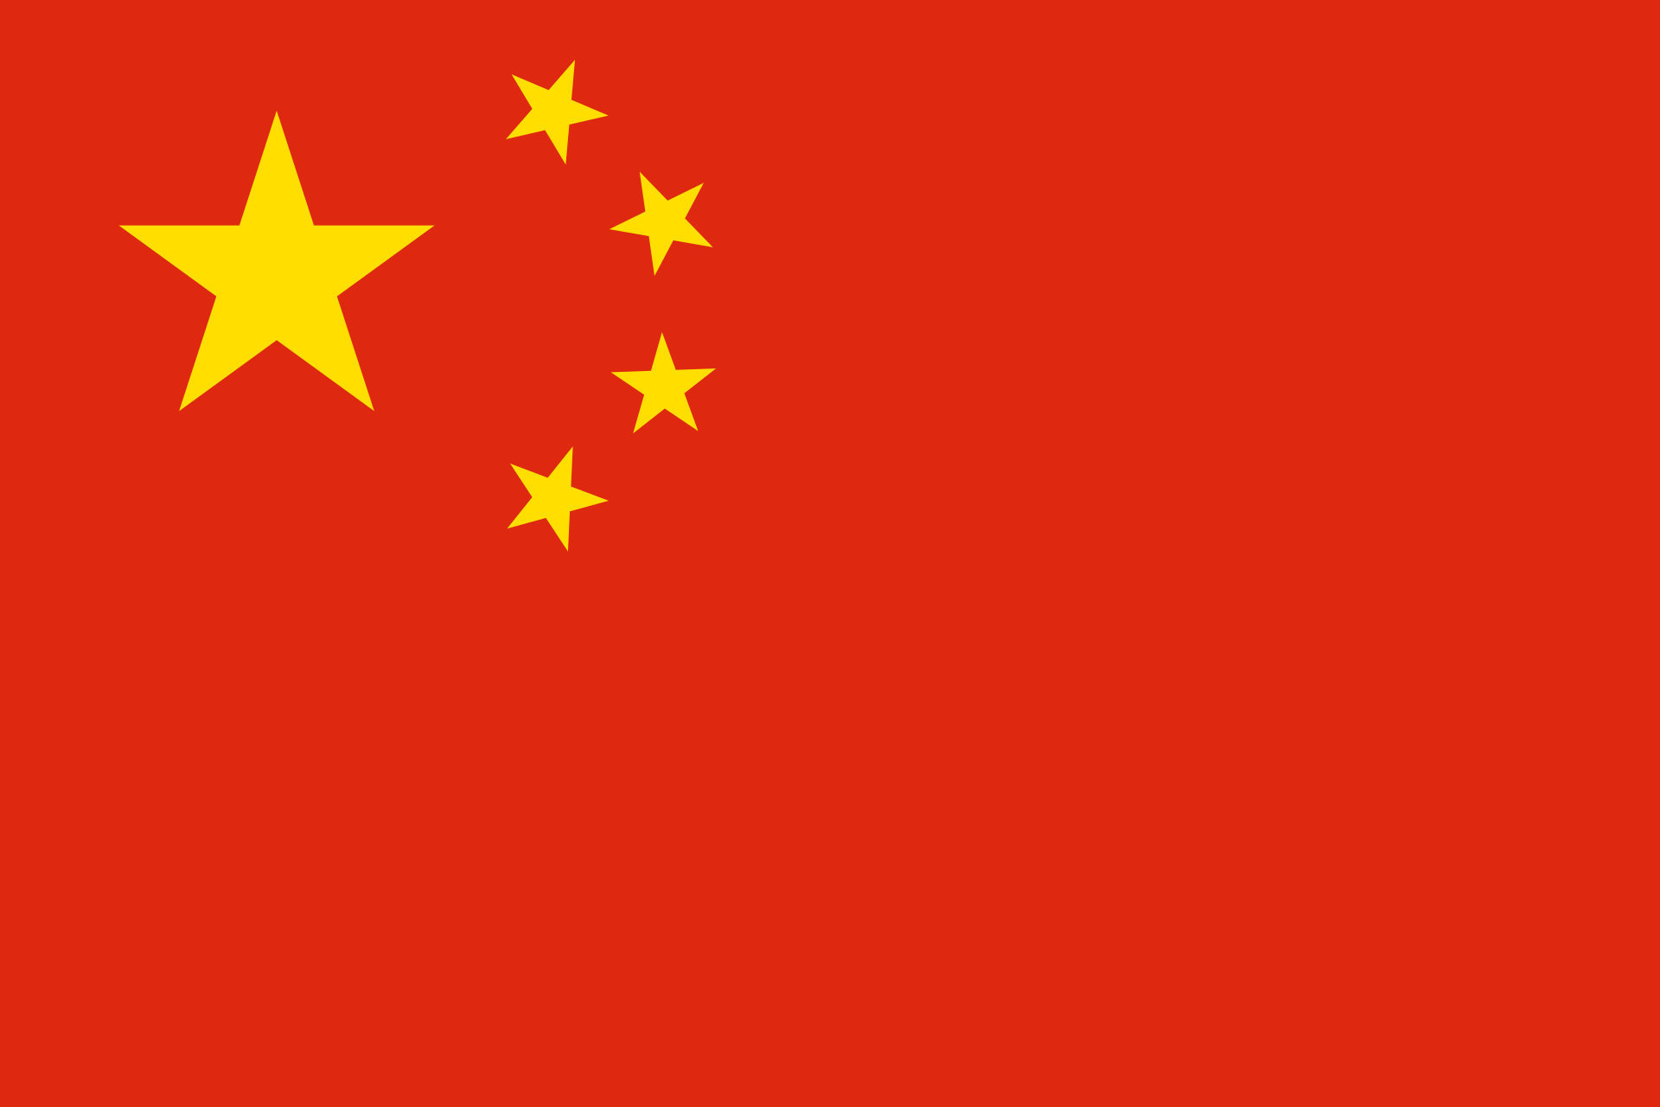
People's Republic of China

We believe that libraries and museums as well as educational institutions are providing public information and the copyright and limitations & exceptions are the important pillars of such purpose. During the pandemic it is further highlighted that it benefits the public interests and also provides a balance in the structure of the public domain and the interest of the right holders. On that basis China would like to be actively engaged in the SCCR as well in the other regional consultations and other sessions to have a better understanding of the needs of cultural organisations so we can achieve greater consensus on this issue. […]
We very much agree that limitations and exceptions are important for promoting knowledge dissemination, cultural inheritance, and protecting the balance between the rights of authors and the public interest. Therefore, we call for determining the priority of related projects, formulating practical work plans, and advancing the discussion process through in-depth research. […]
Russian Federation

We would like to thank the Secretariat for the work in preparation of the report and the regional seminars and international conference on limitations and exceptions to copyright for libraries, archives, museums, educational and research institutions. We believe that the analytical outcomes of these experts and the member states can be useful. We note that the discussions and statements at these events made it evident that the member states have difficulties with this. This enables us to base ourselves on what's happening in member states at the moment, so that we can formulate general principles on the basis of which it would be possible to harmonize our approach and create an international instrument which will serve as guideline, proposing a solution to this general task in a more effective format. […] I should like to underline that extreme important that we resolve the issue of cross-border issues and look at the legal uncertainties and the differences in legislation between countries, and particularly look at the issue of preservation of cultural heritage in the digital form, and also in accordance with international principles and the system to be used for libraries, archives, museums, educational and research institutions, which can become a guideline for national legislation and activities of the current system of copyright and related rights. We note that the coronavirus pandemic clearly demonstrated to the whole world the significance and importance of digital technology, including long distance access, to content and cross-border use of that content. In accordance with this, the existence of material in digital format needs to be a normal thing. The pandemic also showed up the inadequacies and the lack of a genuine international instrument for copyright and related rights and at a time when the work of millions of libraries and archives was not possible in his traditional format and was even under threat. So we underline that the accepted international guidelines show significant differences in copyright and related rights, and this impedes cross-border access and challenges. […]
South Africa

[Statement on behalf of the Africa Group]

The Africa Group has always maintained that a balanced copyright system is essential for the promotion of culture, science, education and for sustainable development. The Group believes that such a balanced copyright system, which affords the necessary protection to creators while allowing sufficient access to users, is indispensable and should inform the work of this Committee. Limitations and exceptions are critical in ensuring the said balance and we welcome the extensive work that has gone into understanding the limitations and exceptions landscape better, including the regional conferences and the international conference on limitations and exceptions that took place in 2019 –the report of which was considered in the previous session of the SCCR and will be discussed again in this session. The Group believes that concrete progressive future work on limitations and exceptions should be a priority for this Committee. […]

The would like to reiterate that limitations and exceptions are an essential part of the copyright system and are crucial in ensuring a balanced copyright system that caters for the needs of all stakeholders and contributes to social economic and cultural advancement, thus leading to thriving societies. Mr. Chairman, this is critically important to determine a clear way forward on limitations and exceptions so these long-standing challenges related to L&Es can be addressed. We welcome the wealth of information that has been gathered through seminars and the International conference on L&Es and this will assist us when considering future work on this topic. […] Useful though they are, the committee should not limit itself to the suggestions contained in that section of that report [on the seminars and conference]. While it is clear from the report that the work that needs to be done at the national front to develop balanced copyright systems inclusive of L&Es, there is no doubt that international action is necessary to deal with those challenges that transcend national borders and are best attended to by global action. Some of the areas that clearly deserve the committee's attention include preservation of works, cross-border issues, online uses. […]

Trinidad and Tobago

Briefly chair, on the national front, we are pleased that the Copyright Act number 14 of 2020 of Trinidad and Tobago was proclaimed on June 15, 2020 to incorporate the provisions of the Beijing treaty and the Marrakesh treaty into law. […] We value the committee's work on limitations and exceptions for libraries and archives as well as limitations and exceptions for educational and research institutions, and for persons with other disabilities. […]

United Kingdom

[statement on behalf of Group B]

On limitations and exceptions, Group B welcomes the opportunity to continue discussions on the report setting out the outcomes of the regional seminars and international conference on limitations and exceptions, which was presented at SCCR 40. […]
We continue to welcome the work as part of this committee which enables exchange of experiences on limitations and exceptions for library, archives, museums and educational and research institutions. We take note of the discussions and findings set out in this report. This collection of information will be invaluable on our work going forward. In particular, we have looked carefully at the takeaway considerations, the general principles and ideas. We welcome the assessment of copyright as an essential tool to support and reward creativity as well as limitations and exceptions as an essential part of a balanced, copyright framework. […]

United States

The United States believes that the current international framework or copyright exceptions and limitations provides the flexibility consistent with the well-established international standards for countries to adopt with exceptions and limitations to advance their own social, cultural and economic policies. […] The United States believes that informed discussion of exceptions and limitations within the SCCR is useful for member states who are interested in tailoring exceptions and limitations of her own needs and circumstances.
European Union

We strongly believe that libraries, archives and museums play a crucial role in the dissemination of knowledge, information and culture as well as the preservation of our history. We also attach importance to the support of educational and research institutions, and for people with disabilities, both in digital worlds with the existing copyright framework.[…]

