Libraries Serving Persons with Print Disabilities – LPD

Newsletter 02/2020

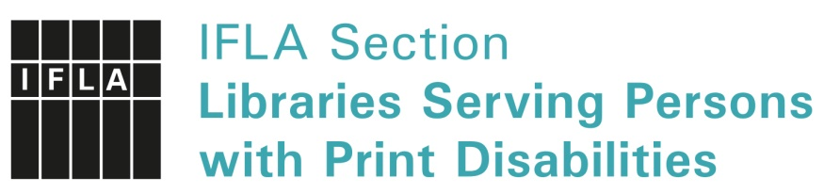
Introduction

Ladies and Gentleman, dear colleagues,
the actual year goes by and it really is time for the second and therefor last newsletter of LPD within 2020. This year was very special all around. Not meeting eachother personally makes it even more important spreading ideas, telling people about the developments and keep updated in a different way. With the newsletter we try one way of communication, there are others too. So please, do not hesitate, tell about what is going on at your institutions, what topics are you working on? Let me know and we will find the right platform: c.felsmann@dzblesen.de.
Have a peaceful and lovely end of the year and please, take care!
Kind regards, Christiane Felsmann
LPD Communication coordinator

Welcome to the second LPD Newsletter this year!

We have not been able meeting at WLIC 2020 because of the cancellation of the congress. Next year’s WLIC will be totally online. We would love to hear your wishes for the topics for next year! Send your ideas to kirsi.ylanne@celia.fi.
LPD has decided to join forces with another IFLA section Library Services to People with Special Needs (LSN) on promoting online accessibility within IFLA. LPD and LSN will form a group that will report and make recommendations for IFLA when necessary.
In this issue we have the following topics,
- how Luisterpuntbibliotheek (Belgium) teamed up with two publishers during the COVID-19 crisis
- how RNIB (UK) new exciting technology embraces
- a survey Dedicon (the Netherlands) carried out about the use and the future of CDs and digital services
- how the Daisy Consortium encourages the use of Born Accessible EPUB 3 files for publications and documents, and
- the centenary of the the Russian State Library for the Blind and the special project ’Library of tactile images for the blind’.
On behalf of IFLA LPD, I would like congratulate the Russian State Library for the Blind on the 100th anniversary!
Enjoy this newsletter, and remember also our social media channels, Facebook group and Twitter. [links to FB and Twitter]
Kirsi Ylänne, LPD Chair

Stronger together: Luisterpuntbibliotheek teamed up with two publishers during the COVID-19 crisis

Never let a good crisis go to waste, Winston Churchill said. The cooperation between Luisterpuntbibliotheek, the Flemish Library serving persons with print disabilities, and two Flemish publishers during the COVID-19 crisis proves that even uncertain and stressful times can deliver great opportunities for creativity and collaboration.
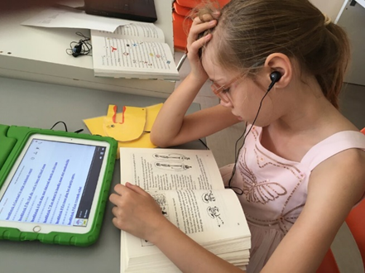
When Belgium went into a complete lockdown on March 13, life came to a standstill. Schools had to suddenly switch to remote teaching. Public libraries had to close down, so teachers and parents immediately went looking for alternative reading material online. A lot of teachers asked Luisterpunt if they could temporarily open up their collection of Daisy audio books to the general public (i.e. not only to people with print disabilities). Luisterpunt contacted Boek.be, the overarching body of Flemish publishers, who quickly reached out to the publishers. Some agreed, some did not, unfortunately. On such short notice it was technically not possible for Luisterpunt to make only part of their collection of Daisy books available for the general public.

De Eenhoorn
Publisher De Eenhoorn, one of the most prestigious publishers of children books in Flanders, regretted this and immediately offered to share the audio versions (from Luisterpunt) of 30 of their books on their website. Books were picked for different age groups and in a few days everything was set up. De Eenhoorn uploaded the audio files to YouTube and embedded the YouTube videos on their website, followed by a link to their webshop to buy the print book. The audio books received thousands of plays.
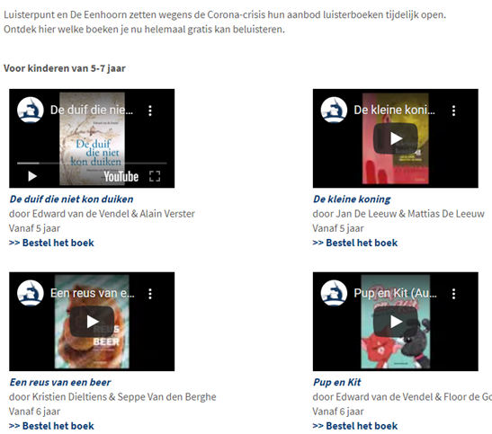
Luisterpunt shared this initiative on their ‘Ik haat lezen’ (‘I hate reading’) Facebook page, which is a campaign aimed at children with dyslexia. The post ‘exploded’: it reached over 140.000 people, was shared 965 times and received more than 2.200 likes.
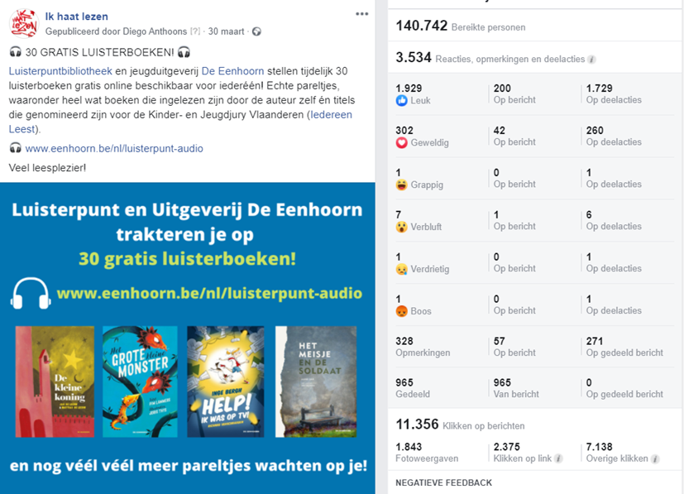

The initiative had advantages for everyone: publicity and possibly extra sales for the publisher, extra reach, followers and goodwill for Luisterpuntbibliotheek, and of course: free audio books for all children, eagerly used within a school context as well.

Uitgeverij Vrijdag
During the summer holiday, Luisterpunt collaborated with another publisher: Uitgeverij Vrijdag. To celebrate the launch of their new website, the publisher offered 30 audio books for adults (from the Daisy collection of Luisterpunt) on their website. This was done in the same way as De Eenhoorn did, with embedded YouTube videos on a web page. A lot of the titles were written by well-known authors and some authors even narrated the audio version of their book themselves.
Uitgeverij Vrijdag was pleased with the campaign, because it generated a lot of traffic to their new website and people started exploring the website after they had visited the page with audio books. Their Facebook post announcing the campaign reached more than 40.000 people. For Luisterpuntbibliotheek, the collaboration was a success as well, because it generated publicity for Daisy audio books for people with print disabilities. And most important: thousands of people were able to enjoy beautiful audio books for free and to forget the stressful circumstances for a while.
The COVID-19 crisis is a challenging time for everyone, but with enough enthusiasm, flexibility, goodwill and an open mind, great things can still be realised. Let’s keep that in mind.
Diego Anthoons
Head of Communications Luisterpuntbibliotheek, Belgium
diego.anthoons@luisterpuntbibliotheek.be, www.luisterpuntbibliotheek.be

RNIB Reading Services

In March 2020 we launched RNIB Reading Services online library. We are delighted to report that we have had a 70% increase in customers using our new online library, compared with the 2019 customer activity on our previous online library.
As part of this new online library we have been excited to, for the first time, offer digital braille to our customers. The keen interest in this from our customers has reassured us that we are pursuing the right path. We will continue to produce physical braille, but we anticipate that we will have the same experience as other countries with strong interest in digital braille as well from our customers.
Our plans were accelerated by the Covid-19 pandemic as we had to suspend our braille library from mid-March to late May and we used that time to contact our braille library customers to ask if they would like an Orbit Reader 20 braille display at no cost to the customer. To date, we have issued circa 300 Orbits and to help our customers get started, we supplied them with an SD card with over 700 digital braille titles on it.
We were interested to find out that customers who had stopped borrowing the physical braille books as they were too heavy have reignited their passion for braille using an Orbit which is lightweight and portable. The positive feedback from these customers has been a boost to our work.
We have put these digital braille titles into our online library and will continue to add more. Providing a digital braille edition of each title has involved a lot of work behind the scenes – joining the individual master files for each braille volume into one continuous book (as a single file, not one of many) and removing the unnecessary information e.g. repeated title pages, content pages, page information messages, so that the reading of the digital braille book is a seamless experience for the customer.
We are in the process of developing smart speaker support, with Sonnar, for our talking book library which we intend to launch in early 2021. Customers have been asking when this will happen, and we will stream our content from our store on the Benetech system. The library team have each taken home a smart speaker to become more confident and fluent in using them and this has worked well for all and had some fun factor as well.
We know our customers are eagerly anticipating the smart speaker solution and for ourselves, it will begin the step towards the future of reducing the requirements of quite so much physical media to be posted back and forth. As we currently despatch an average of 65,000 USBs and 35,000 CDs every month, it will be of interest to see how this evolves during 2021 and beyond.
We are going to start user testing with library members of the Envoy Connect that Vision Australia have successfully deployed to their library members. The ability of the Envoy Connect to hold 30 books rather than the three we currently put on a USB stick will further change our physical production requirements.
Early in 2021, we will move our braille library service to a purely on-demand model, so we will no longer be circulating hard copy braille books but rather we will adopt the same distribution method that a number of other countries have already embraced.
James Bartlett
RNIB Reading Services, UK
www.rniblibrary.com

Preparing for a future without cd’s

In the beginning of 2018 Dedicon conducted a quick survey among service providers and partners* to gauge the effects of the demise of CD-technology on the reading of Daisy books, especially among that section of the elderly who have difficulty handling smartphones or other sophisticated home devices. The main findings were that everybody acknowledges the importance of the issue, and takes it as a fact that the CD will disappear eventually, but not within the coming 5 years. Both producers and retailers of Daisy players confirm that the simple stand-alone Daisy player with CD capacity is still their bestselling products.
All service providers (libraries for the print disabled) report a rapid growth in online delivery combined with a not so rapid decline of CD delivery. Pointing to the fact that a estimated 15% of users of talking books enjoy both means of delivery. Figures over the last 5 years (2015-2019) at Dedicon show a rise in annual demand of online delivery with 600.000 lendings against a decline in demand of CD with 300.000. However, in the same period Bibliotheekservice Passend Lezen (BPL) has seen a rise in membership with around 10.000 new members which warns against a simple interpretation of these figures. More analysis is needed, but it is fair to say that without an active policy from the service providers themselves cd services will stay with us for quite some time. Thereby creating extra costs for the service providers in maintaining and supporting both lines of distribution.
With the exception of Vision Australia (VA), none of the interviewed libraries has communicated a fixed date yet for terminating the CD service. And today VA is the only known library for the print disabled that has terminated their cd services completely. The way they managed this operation contains valuable lessons for all of us who need to make this transition sooner or later. Communication, stable online services (App) and offering a fall-back option for those who can or will not use streaming and download services, are three necessary pillars for making a successful transition.
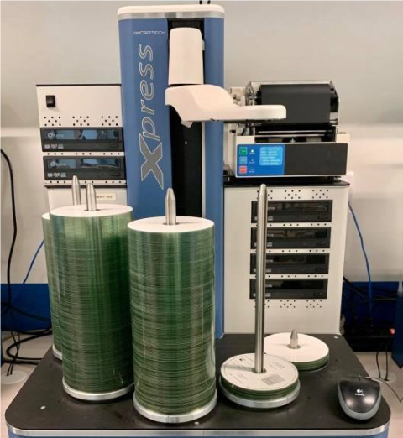
The picture above shows a Daisy robot.
All agree that the segment of the elderly without any online experience will feel the impact of losing the Daisy CD player the most and where a dedicated fall-back solution is indeed necessary. In 2019 Dedicon presented the Envoy Connect player that VA used in its transition, to a group of elderly (average age 83) and asked them what they thought of its use. After explanation and some practical training most of the group including the more vulnerable, could use the basic functions of this offline player, were content with the sound and happy with the size (handy to walk around and for travelling). They wished for bigger buttons and a connection to their hearing aids. The main issue for them (as well as for us!) is how to get new titles on the player. The player has a mini SD port as well as a mini USB port for connecting to a laptop and your virtual bookshelf. Using the SD port means sending SD cards back and forth to the library (not very sustainable) and using the USB connection means being computer savvy enough to go to the internet and connect to your library (not very likely for this group of elderly). Using a download managing desktop App, like the KIOSK app that VA created, is an intermediate solution that might help bridge the gap before the Smart Home devices become good and robust enough for this particular group to use with confidence. Preliminary results of using the Google Home with the same test group showed that speech recognition was not smart enough to understand the given voice commands, and more fundamentally that for this group of testers the concept of calling commands to a sound box was too alien from their thinking. When prompted they expected a dialogue, which, as we all know, is not there yet. The best application they could see for the Google Home was to use it as an intercom to call customer services directly.
In 2021 Dedicon, BPL and its partners and stakeholders will continue the search with the support of the National Library of the Netherlands, this time with the ambition to create a roadmap for the coming years to work towards simple and sustainable alternatives for the good old cd.
Koen Krikhaar
Dedicon, Netherlands
www.dedicon.nl
[* note: for this survey Dedicon contacted 10 service providers / libraries, 3 manufacturers, 4 retail centers and 2 specialists]

News from the DAISY Consortium

The DAISY Consortium has published a white paper encouraging the use of Born Accessible EPUB 3 files for publications and documents.
“EPUB 3 provides the best digital reading experience for everybody on the devices we use today, for both online and offline reading. EPUB 3 can be produced using your existing document processes. EPUB 3 is better, less expensive, and faster.”
It is very interesting for every day use in all kinds of organisations, take a look at the comparison of EPUB 3 and PDF documents for example.

Richard Orme, Daisy Consortium
https://daisy.org

Russian State Library for the Blind: 100th Anniversary of the Era of Accessible Reading

In 2020, the Russian State Library for the Blind celebrates Centenary since its foundation. This is the oldest and largest specialized library in Russia, providing books in accessible formats to Russian-speaking blind people both in the country and abroad.
The fund of the Russian State Library for the Blind has more than 1.5 million items and includes:
  - books and periodicals reproduced in Braille, including publications of the late XIX - early XX century;
  - «talking» books on analog and digital media;
  - movies with tiflokommentaries (audio descriptions), audio tours and other audio resources that provide verbal substitution of visual information that is not available to blind people;
  - relief and graphic manuals, books with tactile illustrations, relief and graphic manuals, 3D models;
  - books with enlarged font, adapted high-contrast illustrations;
  - flat-print books, newspapers and magazines, and other documents.

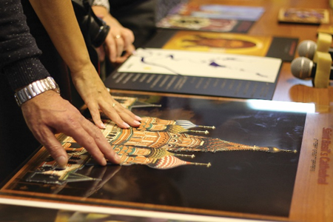 | 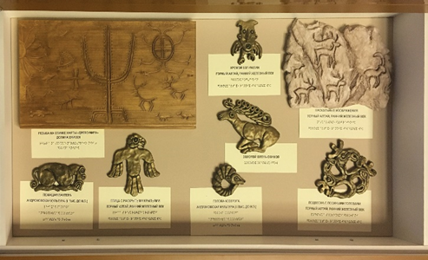

The Russian State Library for the Blind is a research, methodological and publishing center. One of the most important tasks of the Library is to create a barrier-free socio-cultural environment for people with disabilities, their social adaptation, rehabilitation and integration into society. This activity is carried out in several main areas:

- guided tours of by the library and museum collections with tiflokommentaries;
- holding literary and musical events, reading conferences, exhibitions of works of art by professional sculptors, artists, designers, as well as creative works of library users;
- providing users with resources in special formats that are accessible to the blind and visually impaired, including by reproducing current publications of various subjects in relief-dot font (Braille) and in voiced form («talking» book);
- use of adaptive technical means and computer technologies that provide compensation for visual impairment. The library participates in the project of testing of new technical and software innovations products organized by the Innovation Center of the Moscow Government.
Remote service technologies developed by the Library provide additional convenience for people with disabilities. Especially in the extreme conditions in which we all found ourselves in 2020.
In an effort to develop the range of resources and services available to blind people, the Russian State Library for the Blind implements various projects, including:
- supplementation of the collection of the Library's Department of tactile perception of works of art, creating tiflokommentaries for expositions, conducting thematic excursions;
- creating the Electronic library of music scores published in Braille to help students and professional musicians, music teachers for the blind;
- development of the electronic library of «talking» books, including by recording books in the Library's sound studio;
- creating copies of works of art, mathematical models and other tactile objects on a base of the Library's three-dimensional modeling laboratory;
- engaging blind children in reading at the Library's Early Intervention Center;
- reproduction of children's books in raised-dot font with tactile illustrations for post-school and extra-curricular family reading;
- production of educational tactile handmade books with sound accompaniment of popular science and cultural and historical orientation.

One of the latest projects of the Russian State Library for the Blind is the creation of the database «Library of tactile images for the blind» (http://www.3dblind.ru). Database has a complex structure, implying the storage of digital objects, a description of each object in text and audio, a search system with advanced functions, different levels of access to the files of objects (according to the copyright law).
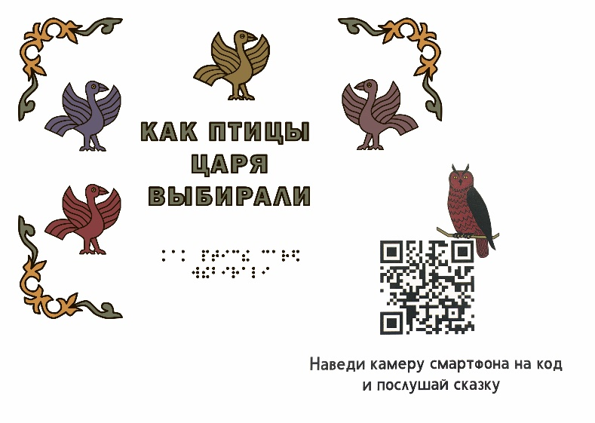
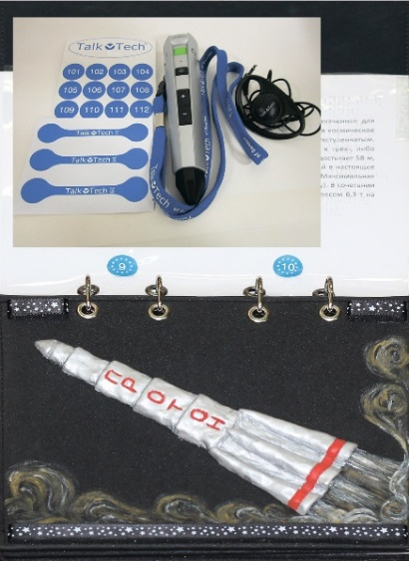

Objects are a presented in STL format (3D printing), PDF (for printing on thermal machines). The Library of tactile images for the blind includes objects covering various spheres of scientific knowledge, culture and art. For example, mathematics, architecture, painting, theater productions, and others.
As a result of the project, not only readers of the Russian state library for the blind, but also blind people and specialists working with disabled people in regional libraries, schools, rehabilitation centers and other institutions will have access to the Library of tactile images for the blind.
The Russian State Library for the Blind as a research and methodological center accumulates domestic and foreign experience in the field of defectology, typhlopsychology and typhlopedagogics, which can be found in the library's service departments, as well as through the database «Virtual typhlologist». The Library pays special attention to the practical implementation of the principles of the Marrakesh Treaty in Russia.
In accordance with the Marrakesh Treaty, a number of changes have been made to the Civil Code of the Russian Federation. A Government Decree on the list of special formats and rules for Internet service has been approved. In 2019, the Russian State Library for the Blind signed an agreement with the Consortium ABC. Technical compliance of formats is currently being discussed.

Galina Elfimova
Deputy Director Russian State Library for the Blind
http://rgbs.ru

On our own behalf: This newsletter may be translated in any language. For the use of anybody else, please send a copy to c.felsmann@dzblesen.de so to publish it on the website http://www.ifla.org/LPD. Thanks for your help.

