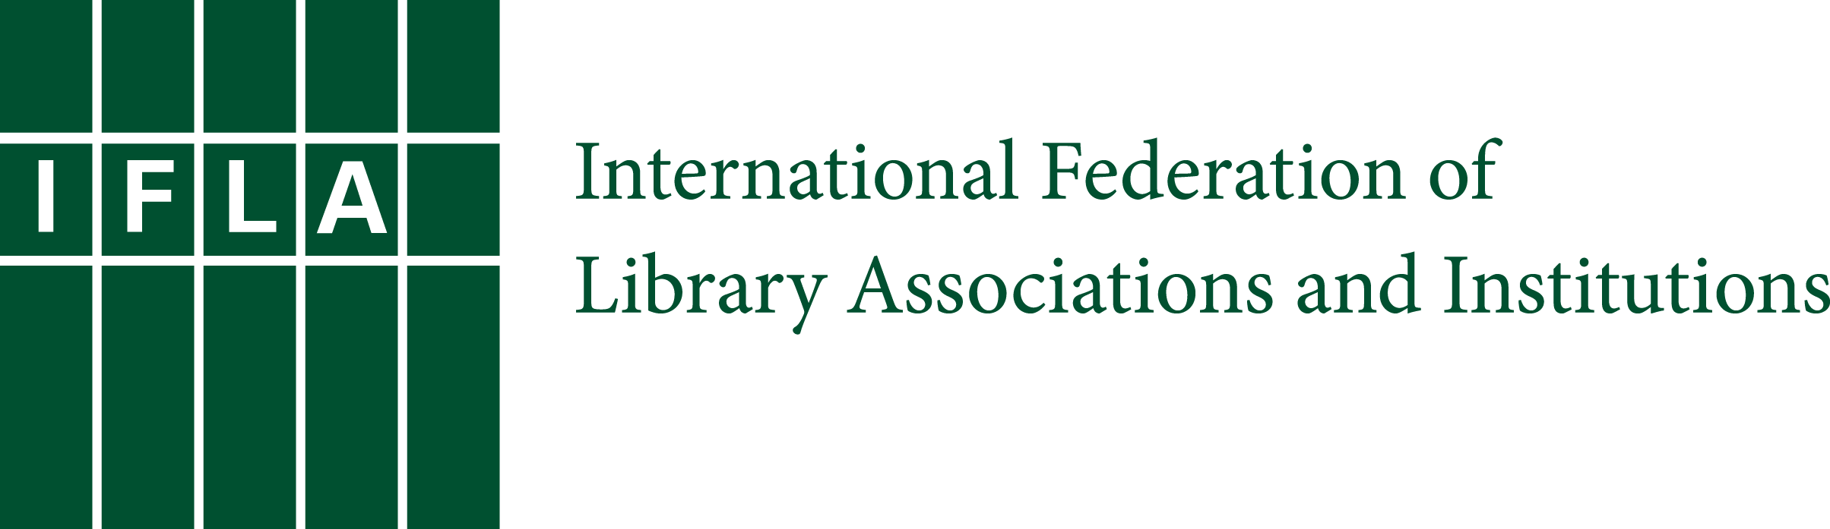

Toolkit: Libraries, Development
and the United Nations 2030 Agenda

August 2017: Revised version

Introduction: How to use this toolkit

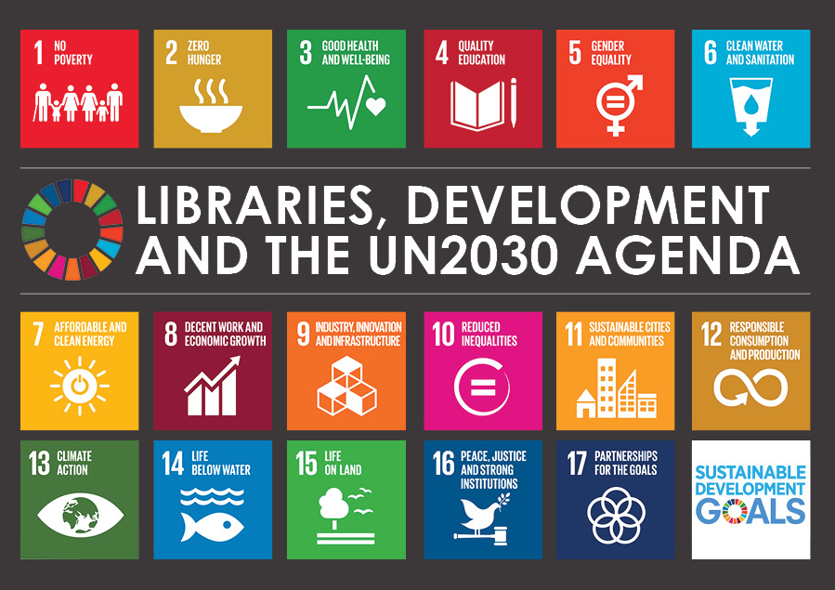
Libraries make an important contribution to development. The purpose of this toolkit is to support advocacy for the inclusion of libraries and access to information as part of formal national and regional development plans that will contribute to meeting Transforming our world: the 2030 Agenda for Sustainable Development (“UN 2030 Agenda”).

Libraries must show that they can drive progress across the entire UN 2030 Agenda. While the Sustainable Development Goals (SDGs) which lie at its heart are universal goals, each country is responsible for developing and implementing national strategies (National Development Plans) to achieve them, and will be expected to track and report its own progress toward each target.

As these plans are developed, the library community in each country will have a clear opportunity to communicate to their government’s leaders how libraries serve as cost-effective partners for advancing their development priorities. Advocacy is essential to secure recognition for the role of libraries as engines of local development, and to ensure that libraries receive the resources needed to continue this work.

Take action in your country to make sure libraries have a say as governments decide how to implement the SDGs:

- Participate in national consultations on national development plans
- Raise awareness about the important role libraries play in development
- Meet with policymakers to advocate for libraries and the UN 2030 Agenda

Purpose of this toolkit

This toolkit is primarily intended to help libraries get involved in national advocacy activities. It will also be of interest to librarians advocating at the local level, and organising activities to increase awareness of the UN 2030 Agenda in their own community.

This toolkit will help you to:

- Understand the UN 2030 Agenda process, and IFLA’s advocacy;
- Understand how the UN 2030 Agenda is being implemented at the national level;
- Organise meetings with policymakers to demonstrate the contribution libraries and access to information make to national development, and across the SDGs;
- Monitor the UN 2030 Agenda and implementation of the SDGs;
- Tell library users about the 2030 Agenda and the SDGs.

Thank you, and next steps

As a result of advocacy by IFLA, our members, Lyon Declaration signatories, coalition partners in civil society and UN Member States, access to information has been recognised as a target under Sustainable Development Goal 16: Promote peaceful and inclusive societies for sustainable development, provide access to justice for all and build effective, accountable and inclusive institutions at all levels:

Target 16.10: Ensure public access to information and protect fundamental freedoms, in accordance with national legislation and international agreements.

Culture (target 11.4) and ICT (targets 5b, 9c, 17.8) have also been included in the SDGs.

Half of the world’s population lacks access to information online. In our knowledge society, libraries provide access and opportunity for all.

And, universal literacy is recognised in the vision for the UN 2030 Agenda.

We envision…a world with universal literacy.

Recognition by the UN is just the first step. The hard work really began when the SDGs started to be implemented by governments on 1 January 2016.

Advocacy at the national and regional level is essential to ensuring that governments recognise and commit to supporting access to information and libraries as they implement the SDGs.

1. Understanding the UN 2030 Agenda and IFLA’s advocacy

Background

In September 2015, after more than three years of negotiations and intense involvement from many stakeholders, including IFLA, the Member States of the United Nations adopted the post-2015 Development Agenda to succeed the Millennium Development Goals, Transforming our world: the 2030 Agenda for Sustainable Development.

The UN 2030 Agenda is an inclusive, integrated framework of 17 Sustainable Development Goals (SDGs) with a total of 169 Targets spanning economic, environmental and social development. They lay out a plan for all countries to actively engage in making our world better for its people and the planet.

The UN 2030 Agenda will help all UN Member States focus their attention on poverty eradication, climate change, and the development of people. By achieving this Agenda, no one will be left behind. All countries in the world must achieve the Goals. The UN 2030 Agenda is a political commitment, which means that everyone, including libraries and civil society, will have a role in making sure governments are accountable for implementing the SDGs.

Libraries support many aspects of The UN 2030 Agenda’s vision and the SDGs. Libraries are key public institutions that have a vital role to play in development at every level of society.

The UN 2030 Agenda includes:

- Declaration
  - Vision of the world in 2030

- Sustainable Development Goals (17 goals, 169 targets)
  - What the world needs to achieve by 2030 – from eradicating poverty to good education, sustainable cities, peace and justice

- Means of Implementation
  - Who is going to pay, and how much it will cost

- Follow-up and review – including global indicators
  - How we know which countries are on track in meeting the Goals

IFLA’s advocacy

Increasing access to information and knowledge across society, assisted by the availability of information and communications technologies (ICTs), supports sustainable development and improves people’s lives.

IFLA has been advocating over the past years to ensure that access to information, ICTs, culture and universal literacy are included as part of the UN 2030 Agenda.

These are issues IFLA has always advocated – the SDGs are an important way to advance access to information and libraries as all governments have agreed to meeting the SDGs, but IFLA will also continue to advocate and build capacity through a number of other forums.

For more information, check: www.ifla.org/libraries-development

Timeline to 2030

The timeline (Figure 1) shows the major milestones that led to adoption of the UN 2030 Agenda in September 2015, and the timeline after implementation beginning on 1 January 2016.

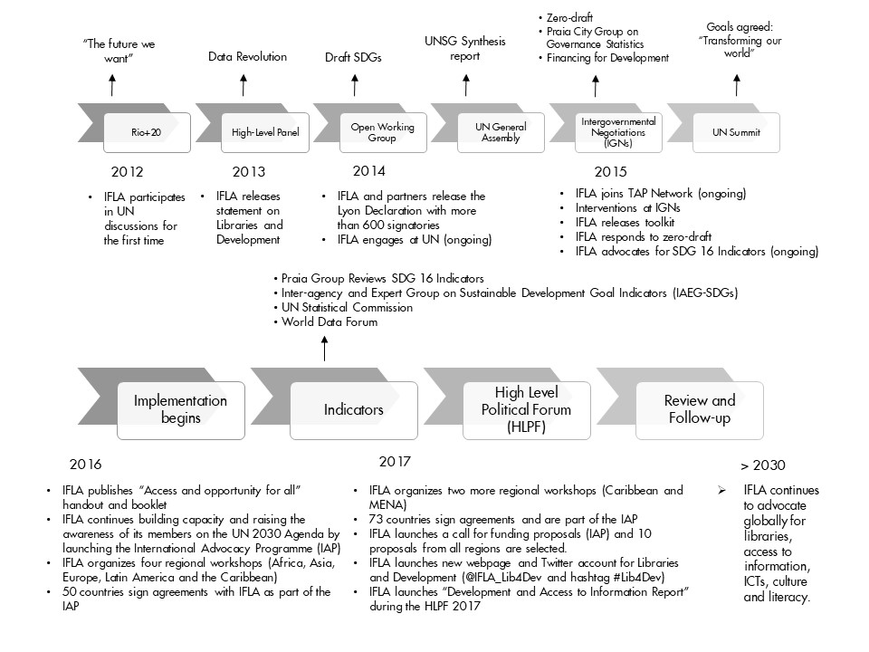

Figure 1. Timeline to 2030

The timeline shows that there are processes which will impact the implementation, monitoring and review of the UN 2030 Agenda. IFLA continues to engage with the development of follow-up and review processes including:

Indicators

Indicators will be used to measure progress towards meeting the SDGs. To ensure that governments are on track with meeting targets 16.10 (access to information), 11.4 (safeguarding cultural heritage) and 4c (universal literacy), IFLA has contributed to consultations on appropriate indicators for access to information, ICT, culture and literacy indicators. Refer to Appendix 4: Indicator proposals.

High-Level Political Forum

Progress towards meeting the SDGs will be monitored every year by the UN High-Level Political Forum (HLPF), beginning in 2016. IFLA will follow this process and engage in consultations on progress towards meeting targets on access to information, ICT, culture and literacy.

Development and Access to Information (DA2I)

IFLA, in partnership with the partnership with the Technology & Social Change Group (TASCHA) at the University of Washington Information School, will measure the impact of access to information and report on progress towards meeting the progress countries are making towards fulfilling their commitment to promote meaningful access to information as part of the United Nations Sustainable Development. The DA2I is a tool for national, regional and global advocacy initiatives related to access to information and libraries. Refer to Appendix 5: Development and Access to Information (DA2I) Report 2017.

2. Understand how the UN 2030 Agenda will be implemented at the national level

National Development Plans

National Development Plans should shape government spending and programme priorities. These plans can include a single national development plan, or individual plans covering broadband, digital inclusion, or social development, amongst others.

Access to information and libraries support poverty eradication, agriculture, quality education, health, public access to ICT and universal service provision, culture, economic growth and all other Goals. By demonstrating the contribution libraries make across the Goals, libraries will be in the best position to partner with government and others to implement national strategies and programmes that benefit library users.

Access to information is a cross-cutting issue that supports all areas of development, and a well-supported library network has a unique role in helping to achieve this.

If access to information and libraries are not included in National Development Plans, it's more than a missed opportunity. Governments may focus on less sustainable approaches – hand-outs, tighter control over social, economic and political life – which do not empower individuals to make their own decisions, based on access to information. Even if they do recognize the value of access, they may overlook libraries and fund other organisations to provide public access, information and skills. Through this toolkit, you will be able to demonstrate the value of libraries in meeting health, educational, economic and cultural goals, and to advocate to government about the need for adequate resources to provide high-quality library programmes and services.

More examples and talking points for each Goal are available in the booklet and handout “Access and Opportunity for All: How Libraries contribute to the United Nations 2030 Agenda”.

Implementation process and government priorities

Each country will take a different approach to implementing the SDGs. They will also adapt and localise the SDGs for local contexts. National governments will emphasize or deemphasize various goals depending on the local situation, and will create and set local targets. They will also create national, localised indicators to measure progress, towards national priorities, with the SDGs as a more or less explicit part of this. It is important to research the process in your country, who is responsible, and your government’s priorities in SDG implementation.

Countries will be supported by the United Nations Development Group (UNDG), United Nations Development Programme (UNDP) and others to mainstream the UN 2030 Agenda at the local level and to target priority areas within the Agenda.

These approaches can be broadly summarised as:

Summary of approaches to implementing the SDGs
Process | Suggested strategy | Example countries | Policymaker to target for meetings
1. New national development plan | Country will formulate a new national development plan using the SDGs and regional plans as the basis.  Get involved in the consultation process  Emphasize the contribution access to information makes across the SDGs;  Use other declarations to support your advocacy including the Cape Town Declaration and the Lyon Declaration on Access to Information and Development. | Tanzania  Uganda | Minister or senior staff member responsible for SDGs. May be located in Ministry of Foreign Affairs, National Development, or another Ministry or Department.
2. Existing national development process | SDGs will be incorporated into existing national development process. | Zimbabwe  Colombia  Gabon  Indonesia | Minister or senior staff member in national development Ministry or Department
3. Variety of plans and processes | SDGs will be integrated across different portfolios and policies as these countries do not have a single national development plan. Policies may or may not be updated to specifically reference the SDGs. | United States  United Kingdom  Australia  Germany | Minister or senior staff member in targeted Ministries or Departments, eg Health, Education, Culture, Social Inclusion
4. Not yet known | It is not yet known what the process will be. |  | Visit the website of the UN Permanent Mission in your country where announcements may be published.  Contact your UN Country Team and your Focal Point listed in the Sustainable Development Knowledge Platform.

Other related processes

The SDGs do not stand alone – they will be integrated with other development priorities in many countries. Other development processes, including at the regional level, are related to the SDGs or will help meet the SDGs. For member countries in these processes, as highlighted above, there may be existing approaches, at the national or regional level, or with a thematic focus, that will shape how your country approaches implementation, support decision-making, and even provide the necessary process. These include, but are not limited to:

Regional Integration Efforts: Africa Union Agenda 2063: The Africa We Want

The Africa Union has identified a number of areas for ‘convergence’ between the SDGs and 2063 Agenda: The Africa We Want, through the work of the Common Africa Position on the post-2015 development agenda. Similarly, ASIAN and the European Union also have long-term plans which look to set priorities and monitor progress towards them.

Open Government Partnership (OGP)

The OGP is an international organization that works with the governments of member countries to make strong commitments to transparency, civic participation, fighting corruption, and open, accountable government. The Partnership has released a declaration calling on OGP member countries to use National Action Plans to adopt commitments that serve as effective tools for implementation of the Sustainable Development Goals (SDGs). OGP have committed to integrating Goal 16 in OGP Naitonal Action Plans. Countries such as Moldova, Georgia and Ukraine already have access to information and library commitments as part of their OGP Action Plans.

Organisation for Economic Co-operation and Development (OECD)

The OECD will support its 34 Member countries through policy coherence, support for partnerships, strengthening data availability and adapting existing assessment tools such as Programme for International Student Assessment (PISA) to the SDGs.

Related development processes on climate change and financing

The Third UN World Conference on Disaster Risk Reduction held in Sendai, Japan in March 2015 has developed a global agenda for that topic. This is important for the development and safeguarding of cultural heritage. The Addis Ababa Action Agenda framework for financing for development was agreed in Ethiopia in July 2015. This framework called for the creation of an open access knowledge-sharing platform, which IFLA supports. A global agreement was reached at the COP21 conference on climate change in Paris, in December 2015. Similarly, initiatives such as HABITAT III, relating to urban development and communities and others provide a global framework for analyzing and responding to national challenges.
A number of UN agencies have a special, cross-cutting role as regards the SDGs:

UN Regional Commissions

The United Nations Regional Commissions will be an important bridge between global and national levels for implementation, follow-up and review of the SDGs. Their priorities will have an impact on the SDGs in each region. They are potentially important contact points for libraries looking both to understand regional developments, and for offering feedback on how effectively the SDGs are being implemented.

They are the following:
- Economic Commission for Africa (UNECA): https://www.uneca.org/
- Economic Commission for Latin America and the Caribbean (ECLAC): http://www.cepal.org/en
- Economic and Social Commission for Asia and the Pacific (ESCAP): http://www.unescap.org/
- Economic Commission for Europe (ECE): http://www.unece.org/info/ece-homepage.html
- Economic and Social Commission for Western Asia (ESCWA): https://www.unescwa.org/
United Nations World Data Forum

Following one of the main recommendations contained in the report entitled “A World That Counts”, presented in November 2014 by the United Nations Secretary-General’s Independent Expert and Advisory Group on Data Revolution for Sustainable Development, the Statistical Commission agreed that a United Nations World Data Forum on Sustainable Development Data (UN World Data Forum) would be the suitable platform for intensifying cooperation with various professional groups, such as information technology, geospatial information managers, data scientists, and users, as well as civil society stakeholders. The first United Nations World Data Forum was hosted by Statistics South Africa in Cape Town, South Africa in early January 2017. The event will be held every year in a different location.

3. Organise meetings with policymakers

Demonstrate the contribution libraries and access to information make to national development, and across the SDGs.

Take action to organize meetings with policymakers following these steps:
- Identify representatives from the library sector;
- Identify implementation process and government priorities;
- Develop library strategy and key messages;
- Organise meetings with policymakers and participate in consultations;
- Utilize the media, partners and champions;
- Monitor the process.

3.1. Identify representatives from the library sector

It is important that the library voice on the UN 2030 Agenda is coordinated and broadly supported at the national level, and aligned with IFLA's international position. Choose two or three senior representatives from the library community to lead on advocacy and organise meetings. For example, leaders from the national library association, national library and/or major public and research libraries.

When selecting representatives, be sure to choose people who not only have legitimacy (due to seniority, who they represent), but also ones who feel knowledgeable and comfortable in such situations. The objective is to create a form of personal relationship, in order to be invited back.

3.2. Identify implementation process and government priorities

Refer to section 2 Understand how the UN 2030 Agenda will be implemented at the national level for further guidance on your country’s planning process to identify policymakers, priorities, and planned activities to implement the SDGs. Processes will vary from country to country, and you are the best placed to know what is going on.

3.3. Develop a library strategy and key messages

To ensure that the message in favour of access to information is strong across the world, it is important to focus on national priorities, and to include points from IFLA’s global messages in your meetings. Refer to Appendix 2: Briefing/handout: Libraries and access to information make an important contribution to national development for more details.

It may be necessary to make some adaptations in different country or cultural contexts, or to bring in more national examples. Feedback on this to IFLA is critical.

Plan the meeting and do your research:

- What do you know about the person you will meet with (personal priorities? Preference for data, or rather story-telling?), their Ministry or department's priorities and the government's national interests?
- What do you know about existing investments and policies for access to information and libraries in your country?
- Which talking points will be most relevant?
- What’s in it for the representative, or your government, to support access to information? How does access to information benefit your country?
- Who will present each talking point during the meeting?

3.4. Organise meetings with policymakers and participate in consultations

The objective of meetings or participating in consultations is to brief representatives about the contribution that libraries in your country make to the SDGs, and the importance of access to information.

By doing this successfully, libraries will be in the best position to position themselves as partners for government and others in implementing national strategies and programmes that benefit library users.

National development plans shape many government spending and programme priorities. Identify opportunities for libraries to be included.

Identify the policymakers in your country:

- If your country has a Minister or senior staff member appointed to implement the SDGs, or coordinate implementation initiatives, request a meeting with them;
- And, you can also request meetings with other key ministries to gain support for your position. Libraries in most countries work closely with Ministries of Education, Culture, Inclusion, Communication and ICT. They will likely be keen to be involved in such a high-profile process;
- UN Country Teams, particularly the United Nations Development Programme (UNDP) will have an important role in supporting governments to implement the SDGs. Identify and meet with your UN Country Team Contacts.
Participate in consultations

Many countries will organise forums with or formal consultations to discuss the implementation of the SDGs. Take part in any open opportunities. To find out what meetings are planned in your country, follow the media or websites of your national development Ministry, or the United Nations Development Programme (UNDP) in your country.

3.5. Utilize the media, partners and champions

Your advocacy can be more effective if libraries work with the media, partners and champions, so that your position is amplified and reinforced by those outside the library sector.

The media can help build support for your position. If an issue has a high profile in the media, it can often gain the attention of policymakers. Use national or international days (such as the International Day for the Universal Access to Information, 28 September) to write to the media about what libraries are doing.

Partners and coalition organisations can also strengthen your voice. Building a coalition is not essential, but may help to show support for your position. A coalition of library (through the library association) and non-library organisations means that you have an agreement to work together to achieve a specific outcome. It does not need to be a formal agreement, but it should be mutually beneficial. For instance, IFLA participates in coalition with non-library organisations to advance access to information in the Transparency Accountability and Participation Network (TAP Network).

Champions may be decision makers themselves, who can advance your position within a Ministry, or a prominent person (MP, writer, other celebrity for example) who can make your position more visible. Consider whether you have champions that would be willing to work with you.

3.6. Monitor the process

Every country will approach implementation in a different way, and at different times. It is important that you monitor developments in your country in an ongoing basis, to take advantage of opportunities as they arise. Keeping track of developments will also allow you to build up a stronger sense of what is working in terms of convincing decision-makers of the importance of libraries. Whenever you hold an event, contact a journalist, or go to a meeting, try to work out what impact it had.

4. Monitor the UN 2030 Agenda and implementation of the SDGs

The UN’s Member States, in agreeing the SDGs, placed a strong emphasis on the importance of monitoring progress. For this purpose, they established a list of over 200 indicators, allowing them to demonstrate progress (or the lack of it) towards the Goals. In addition, countries are invited to volunteer for national reviews (Voluntary National Reviews – VNRs_ every year. This provides an opportunity to set out the progress they are making, and to take questions from other Member States and NGOs at the High Level Political Forum.

Both of these tools are potentially important for libraries. While the indicators in use could be improved, they do include useful measures such as Internet use and literacy. They provide a useful gauge of broader progress towards library goals.

In parallel, when a country undertakes a VNR, there is potential for libraries to provide input on how effectively they are providing for access to information. Stay tuned for updates from IFLA HQ on this.

Feedback to IFLA

Feedback to IFLA Headquarters will help us to support you as you plan meetings, refine messages, and provide local evidence and case studies. Please contact us when you:

- Plan or hold a meeting with policymakers;
- Need additional background on UN 2030 Agenda, or examples to use in your meeting;
- Need contacts or advice on potential coalition partners in your country;
- Have ideas on what more IFLA can be doing to support you.

Strengthen global advocacy by providing local examples

IFLA and its members are always in need for examples regarding libraries and the 2030 Agenda to be used at advocacy opportunities at the international, regional and national level. We want to ensure that the library and information services in all regions, library types and at all levels are represented. These examples are very useful for the advocacy activities of the whole library community!

The examples should be clearly linked to a specific SDG Goal and Target, have a clear impact on people and the community the library or service serves, and, ideally, be delivered either nationally or regionally through a number of libraries.

Please submit your examples using this survey available in the 7 official IFLA languages: https://www.surveygizmo.com/s3/3311305/Examples-of-how-libraries-contribute-to-the-UN-2030-Agenda

5. Tell library users about the SDGs

“Genuine participation and access to information are cornerstones of empowerment”, United Nations Development Group

Every country is being asked to make sure that everyone knows about the SDGs, and how they apply nationally and locally. Librarians can help. Every librarian has a role in the UN 2030 Agenda to make sure that everyone that visits libraries knows about the Goals:

- Make the Goals famous: Share information about the SDGs at your library. More information about the Goals is available online;
- Learn more about what people in your country want from the Goals at The World We Want and the MyWorld data site
- UN Depository Libraries have an essential role in communicating information and research to help decision makers achieve the Goals.

Appendix 1: Sample letter: Library Associations to contact policymakers

YOUR ORGANISATION'S LETTERHEAD/LOGOS HERE

Name of Minister
Address
Date

Dear (name of Minister or their advisor),

Around the world, public access to information enables people to make informed decisions that can improve their lives. Communities that have timely access to relevant information for all are better positioned to eradicate poverty and inequality, improve agriculture, provide quality education, and support people’s health, culture, research, and innovation.

Libraries guarantee access to information — a cross-cutting target that supports all Sustainable Development Goals (SDGs).

The knowledge society is about more than Internet connections. Worldwide, 320,000 public libraries and more than a million parliamentary, national, university, science and research, school, and special libraries ensure that information and the skills to use it are available to everyone – making them critical institutions for all in the digital age. Libraries provide information and communication technology (ICT) infrastructure, help people develop the capacity to effectively use information, and preserve information to ensure ongoing access for future generations. They provide an established, trusted network of local institutions that effectively reach new and marginalised populations.

In our country, [Library association to add one good example of how libraries in their country support one of the Goals/Targets of the SDGs]
Libraries are ready to support implementation of the 2030 Agenda.

We are writing to seek a meeting with you to discuss how access to information and libraries can contribute to achieving the Sustainable Development Goals in our country. We are available to meet you at your earliest opportunity and hope to stay in contact as the Goals are implemented.

Yours sincerely,

Your Signature

Your typed name
Your role/title
Your organisation, or organisations if multiple organisations are signing the letter

CC (list here others whom you have sent copies of the letter)

Appendix 2: Briefing/handout: Libraries and access to information make an important contribution to national development

Public access to information supports the creation of knowledge societies, and includes the infrastructure, ICT and media and information literacy capabilities that people need to effectively use information, and preservation to ensure on-going access for future generations. In this definition, the type of information that should be provided goes beyond information made available by government or required under Right to Information legislation, but while acknowledging the public's right to access information and data, it is essential to respect the right to individual privacy.

Access to information helps support all the Sustainable Development Goals

Half of the world’s population lacks access to information online. In our knowledge society, libraries provide access and opportunity for all.

Around the world, access to opportunity begins with access to information and knowledge. Public access to information enables people to make informed decisions that can improve their lives. Communities that have access to timely and relevant information for all are better positioned to eradicate poverty and inequality, improve agriculture, provide quality education, and support people’s health, culture, research, and innovation.

Libraries guarantee access to information – a cross-cutting target that supports all Sustainable Development Goals

The knowledge society is about more than Internet connections. Worldwide, 320,000 public libraries and more than a million parliamentary, national, university, science and research, school, and special libraries ensure that information and the skills to use it are available to everyone – making them critical institutions for all in the digital age. Libraries provide information and communication technology (ICT) infrastructure, help people develop the capacity to effectively use information, and preserve information to ensure ongoing access for future generations. They provide an established, trusted network of local institutions that effectively reach new and marginalised populations.
Library services contribute to improved outcomes across the Sustainable Development Goals (SDGs) by:
- Promoting universal literacy, including media and information literacy, and digital literacy skills;
- Closing gaps in access to information and helping government, civil society and business to better understand local information needs;
- Providing a network of delivery sites for government programmes and services
- Advancing digital inclusion through access to ICT, and dedicated staff to help people develop new digital skills
- Serving as the heart of the research and academic community
- Preserving and providing access to the world’s culture and heritage

Libraries are ready to support implementation of the UN 2030 Agenda

Libraries are proven, cost-effective partners for advancing development priorities. Many countries have designated libraries as UN depositories, making them an important venue for information about the UN and the SDGs. Libraries are already supporting progress toward the SDGs:

- Increasing income for small-scale food producers (Goal 2): In Romania, public library staff trained by the Biblionet programme worked with local government to help 100,000 farmers use new ICT services to apply for agricultural subsidies, resulting in US$187 million reaching local communities in 2011-2012.

- Promoting lifelong learning opportunities (Goal 4): In Botswana, public libraries have taken large strides toward supporting government objectives under its National Vision 2016, including introducing ICT access, improving the computer skills of library users, and enabling users to be successful in business, education, and employment.

- Empowering women and girls (Goal 5): The National Library of Uganda has provided ICT training specifically designed for female farmers, ensuring that these women can access weather forecasts, crop prices, and support to set up online markets, in their local languages.

- Ensuring productive employment and decent work (Goal 8): In one year, 4.1 million adults in the European Union used public library computers to support employment-related activities – 1.5 million used library computers to apply for jobs, and more than a quarter of a million secured jobs this way.

Appendix 3: How libraries help achieve the 17 Sustainable Development Goals

More examples and talking points for each Goal are available in the booklet and handout “Access and Opportunity for All: How Libraries contribute to the United Nations 2030 Agenda”.

Goal | Library example
1. No Poverty | Slovenia: The Ljubljana City Library hosts an Employment Information Service (EIS) which helps around 1200 people a year, many of whom are homeless or receiving social benefits, to find a job. The library provides media and information literacy skills and helps them develop their resumes and apply for jobs. As many homeless patrons of the library suffer from drug abuse, the library works closely with the Centre for the Prevention and Treatment of Drug Addiction at the University Hospital of Psychiatry in Ljubljana to support rehabilitation, reintegration and social inclusion.
2. No Hunger | Romania: Librarians trained by Biblionet helped 100,000 farmers get US $187 million in subsidies via new Internet and computer services in 2011-2012. The 1,000+ librarians who participated in training decided to bring the services to their libraries together with local mayors. Most of the mayors understood that this service is in the farmers’ interest. The programme helped farmers learn how to use the technology in libraries to access financial forms and submit them to the government, saving time and money.
3. Good Health | Uganda: Health and medical practitioners in rural Uganda still face challenges in accessing basic information needed to ensure quality health care. The Uganda Health Information Digest published by the Makere University library repackages scholarly information in print format for health workers who cannot access the information online. The Digest includes abstracts on topical disease and health issues. It is distributed to over 1500 health units including hospitals, health centres, dispensaries, health related NGOs, district medical offices, all district health and social services committees and Members of Parliament. The Digest is one of the few sources of up-to-date information in remote areas during outbreaks of disease such as Hepatitis.
4. Quality Education | Sweden: Malmö City Library works to overcome the digital divide and encourage social inclusion and sustainability.  The library’s Learning Centre offers courses called “Get Started!”, where digitally inexperienced users learn  how to open email accounts, get better acquainted with the Internet and adjust privacy settings. The library  has many immigrant visitors, especially unaccompanied minors who can access tools designed to improve  literacy and help them with their homework.
5. Gender Equality | Nepal: READ Information and Resource Centre’s Capacity-building Initiative helps women and girls gain insight into their lives. The empowerment programme includes seminars and workshops on women’s rights, gender equality, health, violence against women and other issues. The library encourages women to sign up for the women’s group, which meets once a month in a separate section of the library where the women feel free to speak their minds. Practical courses include literacy and numeracy, English language, ICT, entrepreneurship skills and hands-on classes in making goods for sale.
6. Clean Water and Sanitation | Honduras: San Juan Planes Community Library plays a central role in bringing safe drinking water to the entire community via a water treatment project they established in the town’s central square
7. Clean Energy | United Kingdom: At libraries in Croydon, Derby and other cities across the UK, users are able to borrow energy monitors to  find out which electrical appliances use a lot of energy, enabling people to change and reduce their energy  use.
8. Good Jobs and Economic Growth | Europe: 250,000 people find jobs through their public library in the European Union each year. Public access to ICT and skills enables people to apply for jobs, as the application process for all jobs has moved online.
9. Innovation and Infrastructure | Latvia: For every dollar invested in public libraries in Latvia from 2008-2010, nearly $2 in value (direct and indirect) was created. The return on investment of computer and Internet use in public libraries was even higher, returning more than $3 for every dollar invested.
10. Reduced Inequalities | Mongolia: Most of Mongolia’s 15,000 blind and low vision people are unemployed. In 2010, Ulaanbaatar Public Library (UPL) and the Mongolian National Federation of the Blind built two recording studios to create talking books in digital DAISY format that has increased the amount of accessible materials, and opened up new worlds of learning for visually impaired people.  The Mongolian Libraries Consortium (MLC) advocated for adoption of the Marrakesh Treaty (2013) to facilitate access to published works for persons with print disabilities, the parliament voted to ratify the Marrakesh Treaty in July 2015.
11. Sustainable Cities and Communities | Mali: In 2013, armed groups occupied Northern Mali and Timbuktu, a city famous for its cultural heritage and its vast amount of public and private libraries with invaluable documentary heritage. To safeguard the manuscripts during the occupation, volunteers smuggled them into safety to Bamako with the help of international support. The manuscripts have since been kept in the capital and are undergoing restoration and digitisation work. Libraries have been at the forefront of evacuating and preserving the unique heritage of Mali.
12. Responsible Consumption | United Kingdom: At libraries in Croydon, Derby and other cities across the UK, users are able to borrow energy monitors to find out which electrical appliances use a lot of energy enabling people to actively change and reduce their energy use.
13. Protect the Planet | United States: The Environmental Health Student Portal, a product of the National Library of Medicine (NLM), National Institutes of Health (NIH), provides a safe and useful resource for students and teachers in grades 6 – 8 to learn how the environment can impact our health. The Web site explores topics such as water pollution, climate change, air pollution, and chemicals.
14. Life Below Water | Indonesia: The National Library of Indonesia has an important role in increasing the level of education and literacy for the population spread amongst thousands of islands where education is harder to access – many library services are provided by boat.
15. Life on Land | United States: "The Biodiversity Heritage Library (BHL) is an ongoing open access digital library for biodiversity literature. BHL’s collection includes more than 46 million pages from over 160,000 volumes of biodiversity literature published from the 15th-21st centuries in over 40 languages. Scientists around the world are using the data to identify new species, map population and ecosystem declines, and inform future climate change models. Such data can be used to inform policies related to conservation, sustainable development, and responsible resource management.
16. Peace and Justice | Moldova: Libraries are contributing to Open Government Partnership (OGP) action plans, a platform between government, civil society and business to drive commitments to open government and accountability. Librarians attend civil society meetings to help develop the country’s national action plan, and to include the role of libraries as a supporter of access to information.
17. Partnership for the Goals | International: The World Bank Group Library provides staff and the global community with access to relevant information & services to foster knowledge transfer, good governance through transparency and accountability initiatives and economic development to bring about shared growth and prosperity worldwide in line with the World Bank Group strategy to end extreme poverty by 2030 and foster income growth of the bottom 40% of the population in every country.

Appendix 4: Development and Access to Information (DA2I) Report 2017

Librarians have long understood that by giving access to information, they improve the lives of their communities. Access allows people to learn, take part in society, make better choices, and innovate. It pays off in every aspect of people’s lives – finding jobs, building networks, staying healthy, and coming up with ways to improve their situation.

The Member States of the United Nations recognised this when they included access as a target under SDG 16. Together, the 17 SDGs offer a comprehensive programme for a better world, with no-one left behind. Factors such as access to information are ‘cross-cutting’ – they promote progress across the board.

More Than Connectivity

For IFLA, access is more than just an Internet connection and device. To make a difference, leaving no-one behind, it needs to be meaningful. Users must to be able to find locally relevant content, in a local language. They should have the skills and confidence necessary to find, apply, and create information. And they must have laws and social norms that protect fundamental freedoms and everyone’s right to participate.

Libraries are crucial to achieving this, from acting as public Internet access points to delivering skills (including on coding, for example). They are trusted spaces, experienced in working with community needs. And they are staffed by trained professionals, dedicated to public service.

Access cannot be taken for granted. Too many people still lack Internet access and computers or smartphones. Skills levels – not least basic literacy – are inadequate in many cases, and many are daunted by what goes on online. Restrictive laws and practices remain. And not all libraries have the funding and laws needed to realise their potential. Investment – of time and resources – is necessary. The pay-off will be major progress towards Sustainable Development.

DA2I – Offering the Evidence Base

The Development and Access to Information (DA2I), launched in 2017 by IFLA in partnership with the Technology & Social Change Group (TASCHA) at the University of Washington Information School, report offers the evidence to back up this message. Delivering on a commitment in the Lyon Declaration on Access to Information and Development, it sets out how meaningful access to information drives development.

Its content is organized in the following sections:
- A framework for measuring meaningful access to information around the world, in terms of physical connectivity, social norms, skills, and protection of free expression and access to information. In this context, it sets out baseline indicators.
- A look at the unique role that libraries can play in delivering access, reaching out to all members of their communities.
- Chapters focusing on how access contributes to achieving key areas of the Sustainable Development Goals.
The report is intended as a tool. IFLA will use it at the UN and in other international settings to promote recognition of the importance of access to information and libraries. It is important to ensure that the statements, recommendations, declarations and guidance issued by such institutions echo the arguments of library associations nationally.

But more importantly, it should serve IFLA’s members. Freely available online, and with a variety of supporting materials planned, it is an affirmation of the role of libraries, and helps underline the connection between our institutions’ work and the SDGs. It should also support the work of IFLA’s International Advocacy Programme participants, and others, in advocating for greater recognition of the role of libraries within institutions, and government.

We therefore invite and encourage you to read the report and other materials, and think about how you could use it. You could:

- Share the DA2I in your newsletter and social media!
- Use it as a basis for discussion within your association – what does development and access to information mean for you, your members, and library users in your country
- Look at your country statistics on the measures of access to information
- Translate the Executive Summary into your language (contact us to get the template to facilitate translation!)
- Present copies or send the link when you are meeting with relevant ministers or senior officials
- Download and learn more about the DA2I: DA2I.ifla.org
Ask us any questions! Contact IFLA at: DA2I@ifla.org

This toolkit is the revised version of the toolkit published in October 2015: “Libraries, Development and the Implementation of the United Nations 2030 Agenda” which updated and replaced the toolkit “Libraries and the post-2015 development agenda” (January 2015). Both earlier toolkits remain online for reference purposes only: https://www.ifla.org/publications/7409
https://sustainabledevelopment.un.org/post2015/transformingourworld. Clearly involvement in other government policy planning also offers opportunities to win recognition and support for libraries.
https://sustainabledevelopment.un.org/sdgs
http://www.lyondeclaration.org/signatories/
https://sustainabledevelopment.un.org/sdg16
http://www.lyondeclaration.org/
https://sustainabledevelopment.un.org/post2015/transformingourworld
http://www.un.org/millenniumgoals/
https://sustainabledevelopment.un.org/post2015/transformingourworld
https://sustainabledevelopment.un.org/sdgs
https://unstats.un.org/sdgs/
http://www.lyondeclaration.org/
http://unstats.un.org/sdgs/
https://sustainabledevelopment.un.org/hlpf
https://DA2I.ifla.org/
https://www.ifla.org/publications/node/10546
https://sustainabledevelopment.un.org/post2015/transformingourworld
A detailed overview of this process is available at: https://undg.org/home/undg-mechanisms/sustainable-development-working-group/country-support/
Ministers and country representatives from Angola, Burkina Faso, Cape Verde, Cote D’Ivoire, Lesotho, Guinea, Madagascar, Malawi, Mozambique, Nigeria, South Africa, South Sudan and Swaziland signed a declaration in support of libraries in the SDGs at the IFLA Congress in August 2015, http://www.ifla.org/files/assets/wlic/2015/documents/cape-town-declaration-of-ministers.pdf
Will include SDGs in next 5 year National Development Plan: http://tz.one.un.org/media-centre/press-releases/157-joint-press-release-seventeen-sustainable-development-goals-launched-in-tanzania-a-peoples-agenda-for-development
Will fully integrate the SDGs into the Second National Development Plan: http://www.silofighters.org/hitting-the-ground-running-the-sdgs-in-uganda/
Already completed comprehensive mapping of SDG targets to national priorities
http://www.un.org/en/member-states/index.html
UN Country Teams, particularly the United Nations Development Programme (UNDP) will have an important role in supporting governments to implement the SDGs. Identify and meet with your UN Country Team Contacts: https://undg.org/home/country-teams/unct-home/
https://sustainabledevelopment.un.org/memberstates
http://agenda2063.au.int/
http://agenda2063.au.int/en/sites/default/files/03_Agenda2063_popular_version_ENG%2021SEP15-3.pdf
http://www.uneca.org/sites/default/files/uploaded-documents/Macroeconomy/post2015/cap-post2015_en.pdf
http://www.opengovpartnership.org/
http://www.opengovpartnership.org/sites/default/files/attachments/OGP_declaration.pdf
http://www.oecd.org/
http://www.oecd.org/dac/sustainable-development-goals.htm
http://www.unisdr.org/we/coordinate/hfa
http://www.un.org/esa/ffd/wp-content/uploads/2015/08/AAAA_Outcome.pdf
http://www.ifla.org/node/9702
http://www.cop21paris.org
http://www.cepal.org/en/pressreleases/eclac-will-support-regions-countries-foster-alliances-and-ensure-success-2030-agenda
http://undataforum.org/WorldDataForum/
https://undg.org/home/country-teams/unct-home/
https://undg.org/wp-content/uploads/2015/10/Mainstreaming-the-2030-Agenda-UNDG-Interim-Reference-Guide-to-UNCTs-7-October-2015.pdf
https://sustainabledevelopment.un.org/topics
https://www.worldwewant2015.org
http://data.myworld2015.org
http://unic.un.org
http://www.lyondeclaration.org
IREX (2013), Librarians, Internet Improve Farmers’ Livelihoods in Romania http://www.irex.org/news/librarians-internet-improve-farmers%E2%80%99-livelihoods-romania
IFLA (2013), The Role of Public Libraries in the Attainment of Botswana’s Vision 2016 http://library.ifla.org/258/1/201-radijeng-en.pdf
Beyond Access (2012) Empowering Women and Girls Through ICT at Libraries http://beyondaccess.net/wp-content/uploads/2013/07/Beyond-Access_GirlsandICT-Issue-Brief.pdf
Public Libraries 2020 (2014) See the numbers http://www.publiclibraries2020.eu/content/see-numbers
http://www.ifla.org/publications/node/10546
http://eng.mklj.si/index.php/special-services/item/1140-the-employment-information-service
IREX (2013), Librarians, Internet Improve Farmers’ Livelihoods in Romania http://www.irex.org/news/librarians-internet-improve-farmers%E2%80%99-livelihoods-romania
http://library.ifla.org/868/
http://malmo.se/larcentrum
http://www.eifl.net/eifl-in-action/empowering-women-and-girls-innovation-award
Beyond Access MDGs report http://beyondaccess.net/wp-content/uploads/2013/07/Beyond-Access_MDG-Report_EN.pdf
http://www.croydonlibraries.com/library-services/cut-energy-bills
Public Libraries 2020 (2014) See the numbers http://www.publiclibraries2020.eu/content/see-numbers
http://www.kis.gov.lv/download/Economic%20value%20and%20impact%20of%20public%20libraries%20in%20Latvia.pdf
http://www.eifl.net/eifl-in-action/right-read; http://www.eifl.net/news/mongolia-votes-ratify-marrakesh-treaty-persons-print-disabilities; http://www.eifl.net/sites/default/files/vip_mongolia.pdf; http://02old.eifl.net/ulaanbaatar-city-public-library-mongolia; http://www.eifl.net/news/mongolia-library-success-sparks-law-change; https://www.flickr.com/photos/eifl/6102628375/in/album-72157641310335394/; https://www.flickr.com/photos/eifl/6103174082/in/album-72157641310335394/
http://www.unesco.org/new/en/culture/themes/armed-conflict-and-heritage/emergency-actions/mali/
http://www.croydonlibraries.com/library-services/cut-energy-bills.
http://kidsenvirohealth.nlm.nih.gov/generic/9/about
http://biodivlib.wikispaces.com/
http://documents.worldbank.org/curated/en/2013/10/18372588/world-bank-group-strategy-vol-2-2-final-report
https://DA2I.ifla.org

